Title: Design and Verification of Processor Datapath Components Using Verilog HDL
Intern Name: Lagisetty Vidya Charan
College: Mohan Babu University
Department: Electronics and Communication Engineering
Internship: VLSI Design Internship
- Objective:
To design and verify basic processor datapath components using Verilog HDL in Xilinx Vivado. The task includes the implementation and behavioral simulation of an Arithmetic Logic Unit (ALU), Register File, RAM, ROM, and an integrated Mini Datapath.
- Software and Tools Used:
- Xilinx Vivado
- Verilog HDL
- Vivado Behavioral Simulation
- Waveform Viewer
- Introduction:
A processor datapath is responsible for storing, processing, and transferring data within a digital processor. It consists of functional units such as registers, arithmetic and logic units, and memory elements.
In this task, individual datapath components were designed using Verilog HDL and verified through behavioral simulation in Xilinx Vivado. Finally, the ALU and register storage were integrated to form a simple mini datapath capable of performing arithmetic and logical operations and writing the generated result back into a register.
- ALU Design
  - Description:
An Arithmetic Logic Unit (ALU) is a combinational circuit that performs arithmetic and logical operations on binary data.
The logical ALU uses:
- Two 4-bit inputs: A and B
- A 3-bit operation select: sel
- One 4-bit output: Y
Operation Table
sel | Operation | Description
000 | ADD | A+B
001 | SUB | A-B
010 | AND | A&B
011 | OR | A|B
100 | XOR | A^B
  - Simulation Result:
For the test case:
A=1010
B=0011
the following results were obtained:
Operation | Expected Output | Simulated Output
ADD | 1101 | 1101
SUB | 0111 | 0111
AND | 0010 | 0010
OR | 1011 | 1011
XOR | 1001 | 1001
All ALU operations produced the expected results.
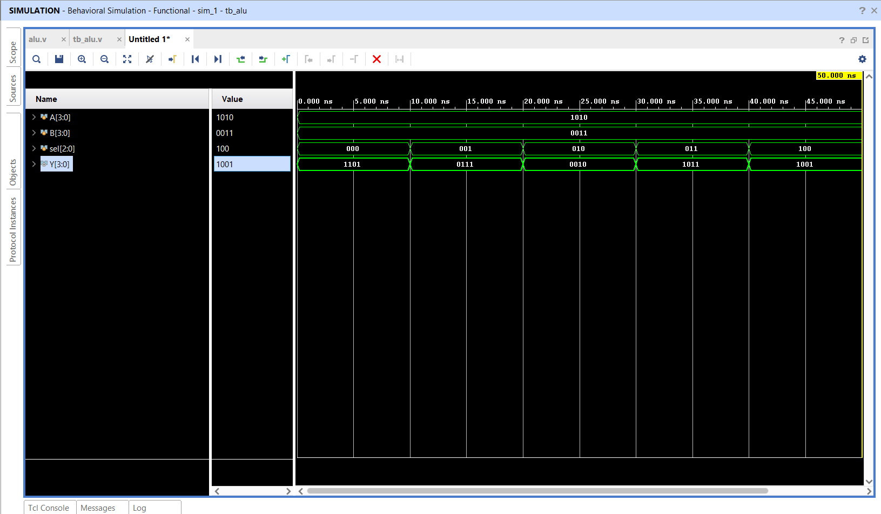
Figure 1: Behavioral simulation of the 4-bit ALU
- Register File Design:
  - Description:
A register file is a collection of registers used for temporary storage of data in a processor.
The implemented register file contains:
- Four registers
- 4-bit data width
- 2-bit address
- Write enable signal
- Clock signal
- Data input and output
The 2-bit address allows selection of four registers:
00 → Register 0
01 → Register 1
10 → Register 2
11 → Register 3
Data is written on the active clock edge when the write enable(we) signal is asserted.
  - Simulation Result:
The simulation verified the data could be written into different register locations and subsequently read from the selected addresses.
The waveform demonstrated correct storage and retrieval of the input data.

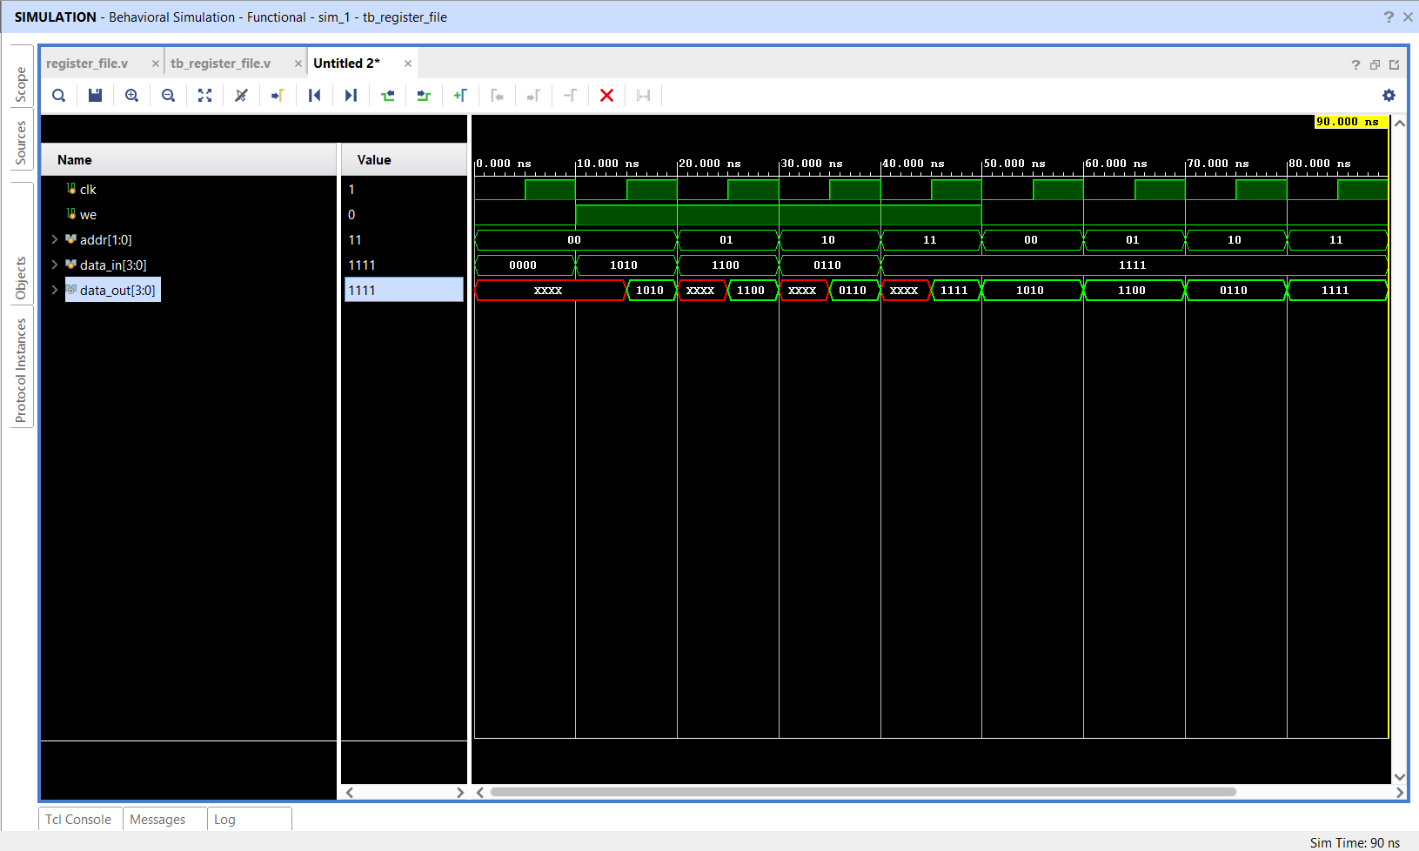
Figure 2: Behavioral simulation of the register file
- RAM Design:
  - Description:
Random Access Memory (RAM) is a read/write memory in which data can be stored and retrieved using an address.
The implemented RAM has:
- 4 memory locations
- 4-bit data width
- 2-bit address
- Clock input
- Write enable signal
The memory operations were verified using different addresses and input data.
  - Write Operation:
The following data was written into the RAM:
Address | Data
00 | 1010
01 | 1100
10 | 0110
11 | 1111
  - Read Operation:
After the write operation, the same addresses were selected for reading.
The corresponding output data was:
Address | Expected Data | Simulated Data
00 | 1010 | 1010
01 | 1100 | 1100
10 | 0110 | 0110
11 | 1111 | 1111
The RAM successfully stored and retrieved the required data.
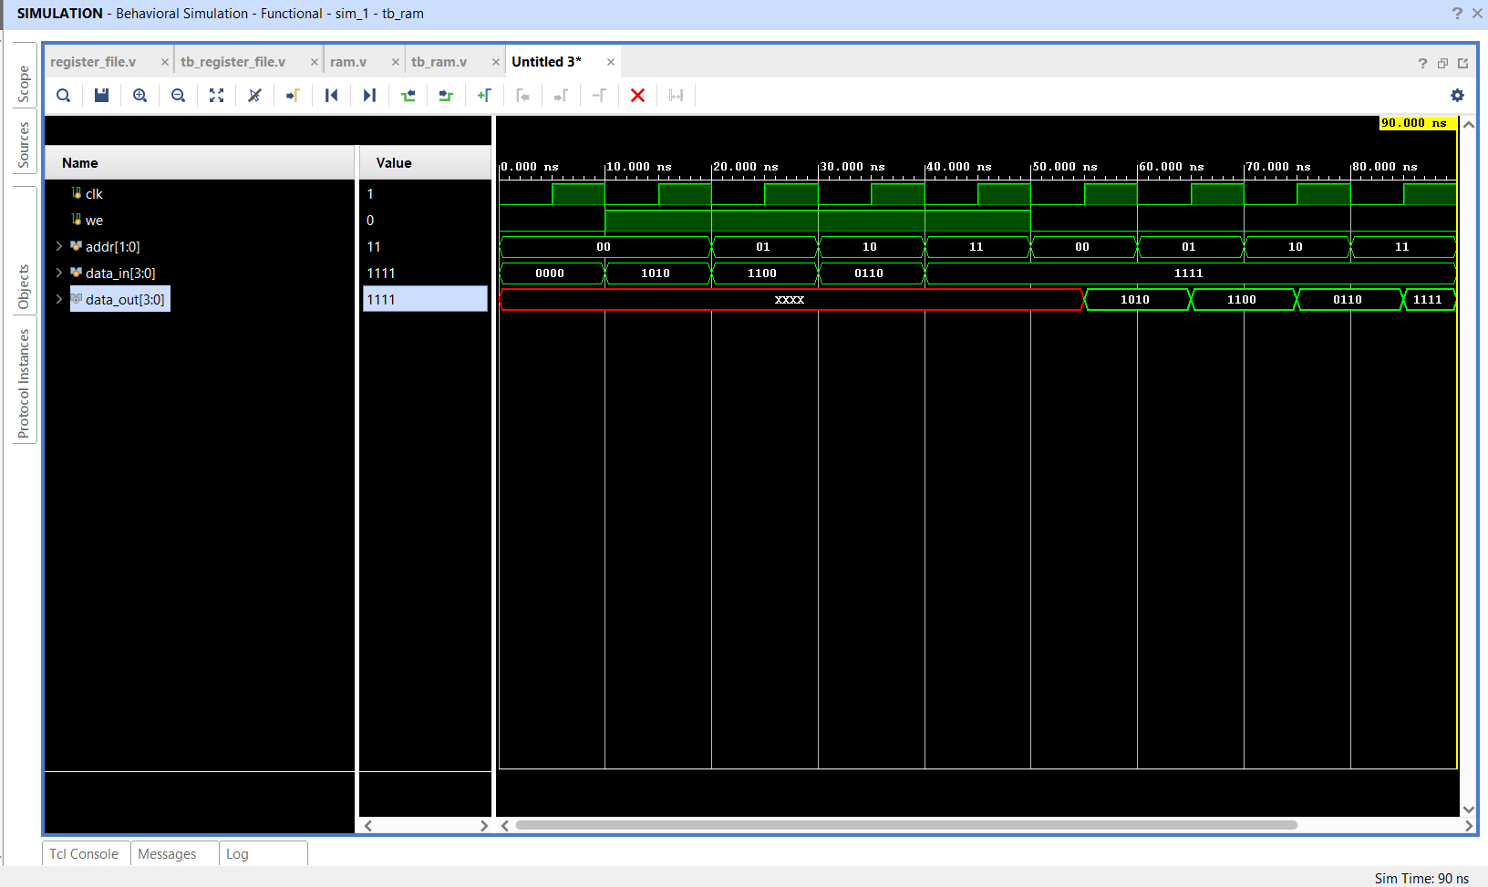
Figure 3: Behavioral simulation of 4x4-bit RAM
- ROM Design:
  - Description:
Read Only Memory (ROM) stores predefined data that can be accessed using an address. Unlike RAM, the implemented ROM does not contain a write operation.
The ROM was designed as a 4 × 4-bit memory.
The predefined contents were:
Address | Data
00 | 1010
01 | 1100
10 | 0110
11 | 1111
  - Simulated Result:
The address was changed sequentially from 00 to 11. The corresponding output changed according to the predefined ROM contents.
Address | Expected Output | Simulated Output
00 | 1010 | 1010
01 | 1100 | 1100
10 | 0110 | 0110
11 | 1111 | 1111
The simulation confirmed the correct address-to-data mapping.

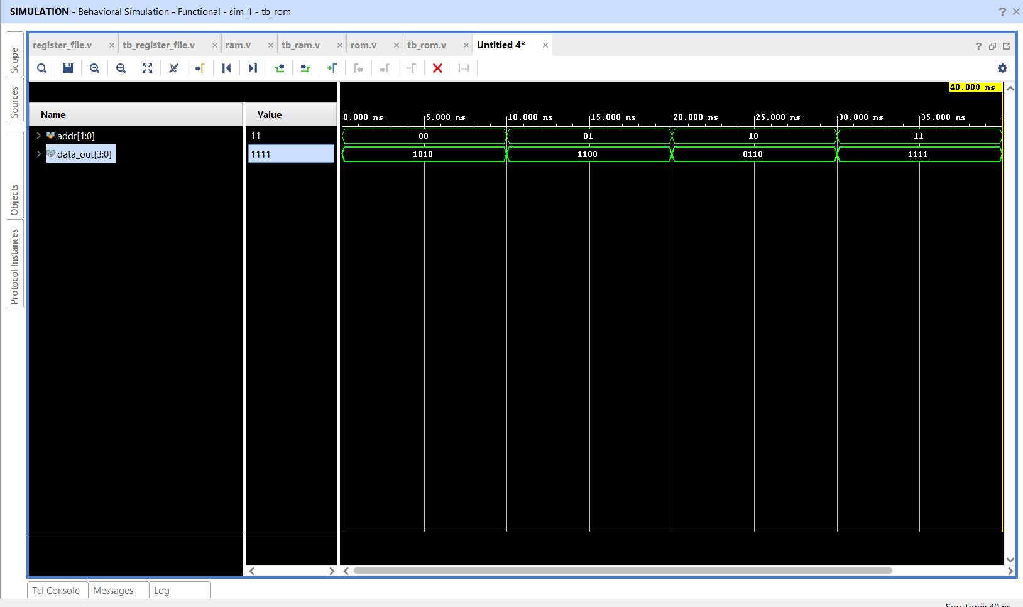
Figure 4: Behavioral simulation of 4x4-bit ROM
- Mini Datapath Design:
  - Description:
After verifying the individual components, a simple Mini Datapath was implemented to demonstrate the interaction between register storage and the ALU.
The datapath contains:
- Register storage
- Two register read addresses
- One register write address
- ALU operation selection
- Write enable
- Clock
- ALU result
The basic data flow is:
Register File
│
├──── Operand A ──┐
│ │
│ ▼
│ ┌─────┐
│ │ ALU │
│ └──┬──┘
│ │
└──── Operand B ───┘
│
Result
│
▼
Write Back
│
▼
Register
- Mini Datapath Verification:
For verification, the following register values were initialized:
R0 = 1010
R1 = 0011
The ALU operations were then performed using R0 and R1
Simulation Results:
Operation | Calculation | Result
ADD | 1010 + 0011 | 1101
SUB | 1010 – 0011 | 0111
AND | 1010 & 0011 | 0010
OR | 1010 | 0011 | 1011
XOR | 1010 ^ 0011 | 1001
All five operations produced the expected outputs.
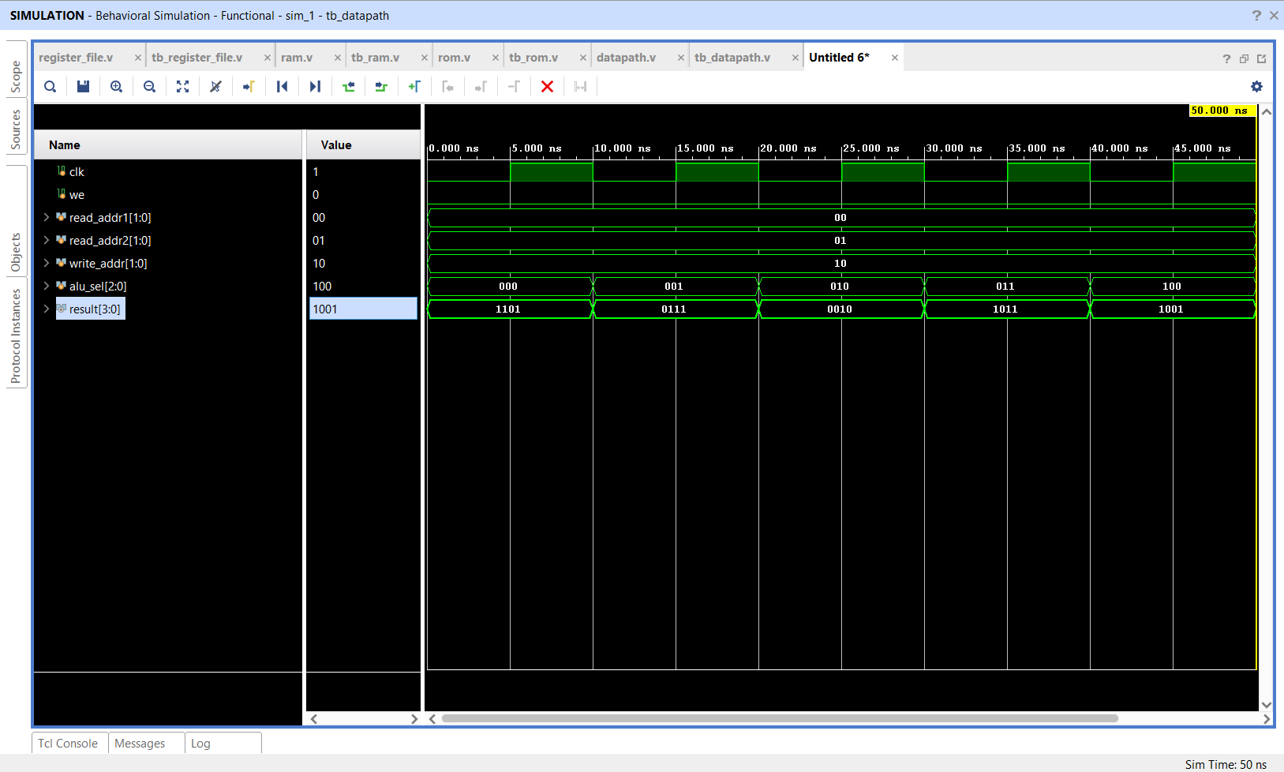
Figure 5: Behavioral simulation of the integrated mini datapath
- Write – Back Verification:
The write-back functionality was also verified.
The ALU was configured for addition:
R0 + R1 = 1010 + 0011
= 1101
The result was written into register R2 by setting:
we = 1
write_addr = 10
Therefore:
R2 ← 1101
The simulation showed:
r2_value = 1101
confirming successful write-back.
The stored value was subsequently accessed through address 10, further confirming that the ALU result had been successfully stored in the register file.
- Results and Discussion:
The individual processor datapath components were successfully designed using Verilog HDL and simulated using Xilinx Vivado.
The ALU correctly performed arithmetic and logical operations. The register file successfully stored and retrieved 4-bit data using address selection. The RAM demonstrated both write and read operations, while the ROM correctly provided predefined data for each address.
The integrated mini datapath successfully transferred operands from the register storage to the ALU and generated the expected results. The write-back test further demonstrated that the ALU result could be stored into a selected register.
The behavioral simulation waveforms confirmed the functional correctness of all implemented modules.
- Conclusion:
The task successfully demonstrated the design and verification of fundamental processor datapath components using Verilog HDL and Xilinx Vivado.
The implemented modules included an ALU, Register File, RAM, ROM, and Mini Datapath. Each module was individually tested through behavioral simulation, followed by integration of register storage and ALU functionality.
The final mini datapath successfully performed arithmetic and logical operations and demonstrated ALU result write-back into a register, completing the functional verification of the designed datapath.

